Northern Long Eared Bat Listed as Threatened
On April 2, 2015, the U.S. Fish and Wildlife Service (USFWS) issued their Final Rule listing of the northern long eared bat (Myotis septentrionalis) as threatened. This listing could affect all development in Virginia and Maryland on sites with forested cover that require a federal action (such as a wetland permit, floodplain compliance, federal financing, federal highway access, etc.). Additionally, the USFWS issued an Interim 4(d) Rule which allows for exemptions for certain activities. However, typical clearing of forested lands for development is not included under these exempt activities.
Background
The northern long-eared bat was formerly common and widespread throughout the eastern and central United States. Populations of this species (as well as other bat species) have declined dramatically since the discovery of white-nose syndrome (a fatal fungus) in bats in New York in 2006. As a result of white-nose syndrome, populations of northern long-eared bat have declined by 99 percent. The USFWS first proposed to list the northern long-eared bat as federally endangered in October 2013 and requested comments from stakeholders and the public regarding the proposed listing at that time. This final rule instead lists the northern long-eared bat as threatened throughout its range (shown in the map below), meaning that it is not in immediate danger of becoming extinct – a ruling that has riled some industries. See our previous Field Notes Article for additional information on the northern long-eared bat. 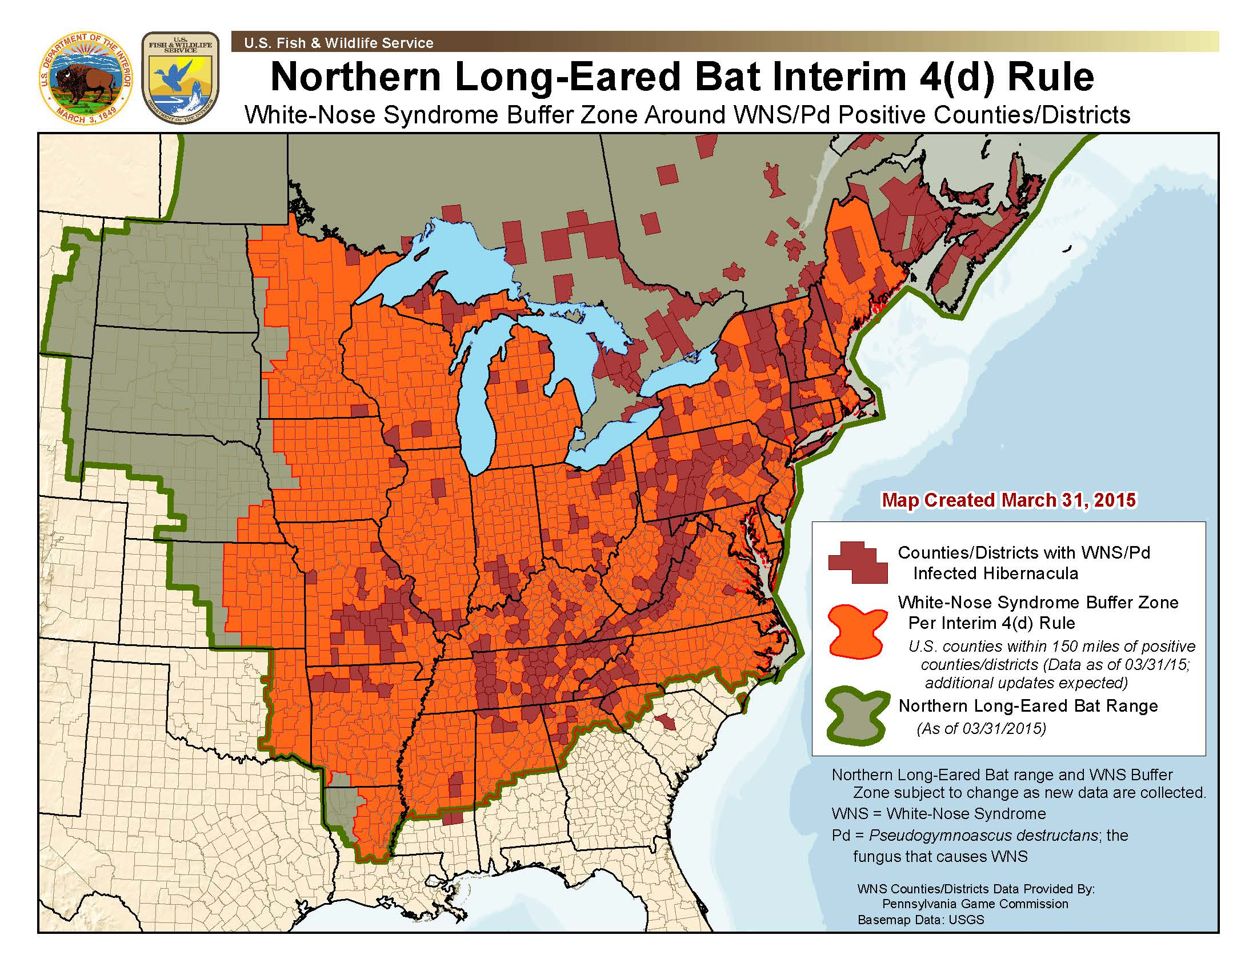
NLEB Range Map and White Nose Syndrome Buffer Zone, courtesy USFWS
How the listing affects your project
Now that the bat has been listed under the Endangered Species Act, it is afforded certain protections. Any action where the species may be “taken” is prohibited without permits for Purposeful or Incidental Take. Because the northern long-eared bat primarily inhabits forests from April to September, the clearing of trees has the potential to “take” the species. Thus, if your project requires a federal action (such as a wetland permit or floodplain compliance determination), and there is known habitat (either a cave for hibernation, or a maternity roost tree) you may not be allowed to clear trees on your property without a take permit or without proving that the northern long-eared bat is not present on your property, and that your action is not likely to adversely affect the bat.
The Interim 4(d) Rule
With the listing of the northern long-eared bat as threatened, the USFWS is also issuing an Interim 4(d) Rule, which allows for exemptions for certain activities, specifically:
- Forest Management
- Maintenance or expansion of existing rights-of-way and transmission corridors (work occurs no further than 100 feet on either or both sides of existing right-of-way)
- Native prairie management
- Minimal tree removal (sites greater than 1-acre will not qualify for this)
- Hazardous tree removal
However, even these “exempt” activities must still comply with certain conditions, specifically: they must be 0.25 miles from known, occupied hibernacula (e.g., caves); they avoid cutting or destroying known roost trees during the pup season (June 1 – July 31); and they avoid clearcuts (and similar methods) within 0.25 miles from known, occupied roost trees during the pup season. Note that even if your project meets one of these exemptions, consultation with USFWS is still required. See the USFWS Key to the Interim 4(d) Rule for more information.
Help! I need a wetlands permit, my activity is not exempt, and I need to clear trees between April 15 and September 15! Now what?!
Because of the large range of the bat, it could potentially occur in all counties in Virginia and Maryland. On sites where suitable habitat is present, and there are known occurrences of the northern long-eared bat in that sites county, USFWS will be requiring surveys. To the best of our knowledge, within Virginia, there are known occurrences in the following counties: Albemarle, Appomattox, Augusta, Bath, Bland, Botetourt, Buchanan, Buckingham, Caroline, Chesapeake, Chesterfield, Craig, Dickenson, Fauquier, Floyd, Giles, Greene, Highland, Lee, Louisa, Madison, Nottoway, Page, Pulaski, Roanoke, Rockbridge, Rockingham, Scott, Shenandoah, Smyth, Staunton, Suffolk, Tazewell, Washington, Waynesboro, Wise, Wythe, and York. Note that USFWS is continually updating this list, thus it is subject to change. In all other counties, USFWS is likely going to require surveys for the bat at all sites where it could be present, though the Virginia Field Office of the USFWS is still working on this determination. A list of known occurrences in Maryland is not publicly available at this time.
In order to determine if there is suitable habitat on your site or if the northern long-eared bat is present on your site, there are several options available. The first is to have WSSI’s qualified biologists perform a habitat assessment. If your site does not contain suitable habitat (and USFWS agrees), it should be possible to commence with work. If suitable habitat is present, then surveys for presence/absence of the northern long-eared bat are necessary. These can take the form of low-intensity acoustic surveys or high-intensity mist-net surveys, both of which must take place between May 15 and August 15 of a given year. If these surveys determine that the northern long-eared bat is not present on your site, it may be possible for work to proceed (assuming USFWS concurs). If these surveys determine that the northern long-eared bat is present on the site, then additional surveys or restrictions may be required.
Note that if you already have your wetland permits in place, the agencies are not currently expected to require that you re-coordinate regarding this new listing, but the onus is still on the property owner to be in compliance with the Endangered Species Act (e.g., if a project opponent challenges the project on the grounds of a violation of the Endangered Species Act, the permittee must be able to show that they are in compliance). However, if you require a permit modification or other new action by a federal agency, endangered species coordination will be re-opened.
The National Association of Home Builders (NAHB) has been tracking this listing, and is requesting that USFWS exempt homebuilding in the Final 4(d) Rule. You can read the NAHB article and provide comment here.
WSSI has staff to ready conduct acoustic surveys to be ready at the start of the 2015 acoustic survey season. Our parent company, Davey, also has trained staff ready to assist with these surveys to help minimize project delays resulting from the listing of the northern long-eared bat, if we need additional resources.
Please contact Ben Rosner, or Mark Headly with any questions you have about this listing or if you would like to arrange for a habitat assessment or survey.

L:\WSSI Marketing & PR Information\Newsletters\2015\03_March\Bat Article and Info\Northern Long Eared Bat Listed as Threatened.docx

The Endangered Species Act defines “Take” as: to harass, harm, pursue, hunt, shoot, wound, kill, trap, capture, or collect, or to attempt to engage in any such conduct.
Note that in Virginia and Maryland, the Time of Year Restriction for northern long-eared bat is April 15 to September 15. You may be able to clear outside of this window, but only with approval from USFWS.

